# Generated Blog Results

## Set 1: "Unveiling Tomorrow: The AI Revolution in Our Lives" - This blog delves into the profound influence of AI on our daily routines and future possibilities with an insightful exploration of its revolutionary impact.

Title: The Transformative Power of AI: Shaping Our Future  
  
Introduction:  
Artificial Intelligence (AI) has become an integral part of our daily lives, revolutionizing the way we work, communicate, and interact with the world around us. From virtual assistants to self-driving cars, AI technology continues to evolve rapidly, leaving a profound impact on various aspects of society. In this blog post, we will explore the significant influence of AI on our lives and the implications it holds for the future.  
  
Main Body:  
1. Enhancing Efficiency in Various Sectors:  
AI has significantly enhanced efficiency in various sectors such as healthcare, finance, and transportation. In healthcare, AI-powered technologies are being used for early disease detection, personalized treatment plans, and medical imaging analysis. This has not only improved patient outcomes but also reduced healthcare costs. Similarly, in finance, AI algorithms are used for fraud detection, risk assessment, and algorithmic trading, leading to more accurate decision-making and increased profitability. Furthermore, self-driving cars powered by AI have the potential to revolutionize transportation by reducing accidents and traffic congestion.  
  
2. Changing the Nature of Work:  
The integration of AI in the workplace has changed the nature of work by automating repetitive tasks and augmenting human capabilities. While this has led to concerns about job displacement, it has also created new opportunities for upskilling and reskilling the workforce. AI can handle mundane tasks, allowing humans to focus on more strategic and creative aspects of their jobs. Additionally, AI has enabled remote work and collaboration through virtual meeting platforms and project management tools, making work more flexible and accessible.  
  
3. Ethical and Social Implications:  
Despite its numerous benefits, AI also raises ethical and social implications that need to be addressed. Issues such as bias in AI algorithms, data privacy concerns, and the impact of automation on job markets require careful consideration. It is crucial to ensure that AI technologies are developed and deployed responsibly, with transparency and accountability. Moreover, there is a need to bridge the digital divide to ensure equitable access to AI-driven solutions for all segments of society.  
  
4. Personalized Experiences and Consumer Behavior:  
AI has revolutionized the way businesses interact with consumers by enabling personalized experiences and targeted marketing strategies. Recommendation systems powered by AI algorithms analyze user preferences and behavior to offer tailored product recommendations and content. This has not only improved customer satisfaction but also influenced consumer behavior and purchasing decisions. Businesses are leveraging AI to gain insights into market trends, optimize pricing strategies, and enhance customer engagement, ultimately driving revenue growth.  
  
Conclusion:  
In conclusion, the impact of AI on our lives is profound and far-reaching, transforming the way we live, work, and interact with the world. While AI presents immense opportunities for innovation and progress, it also poses challenges that must be addressed thoughtfully. By embracing AI responsibly and ethically, we can harness its transformative power to create a more inclusive and sustainable future for all. As individuals, staying informed about AI developments and actively participating in discussions about its implications can help shape a future where AI serves as a force for good in our society.

### Cover Image:

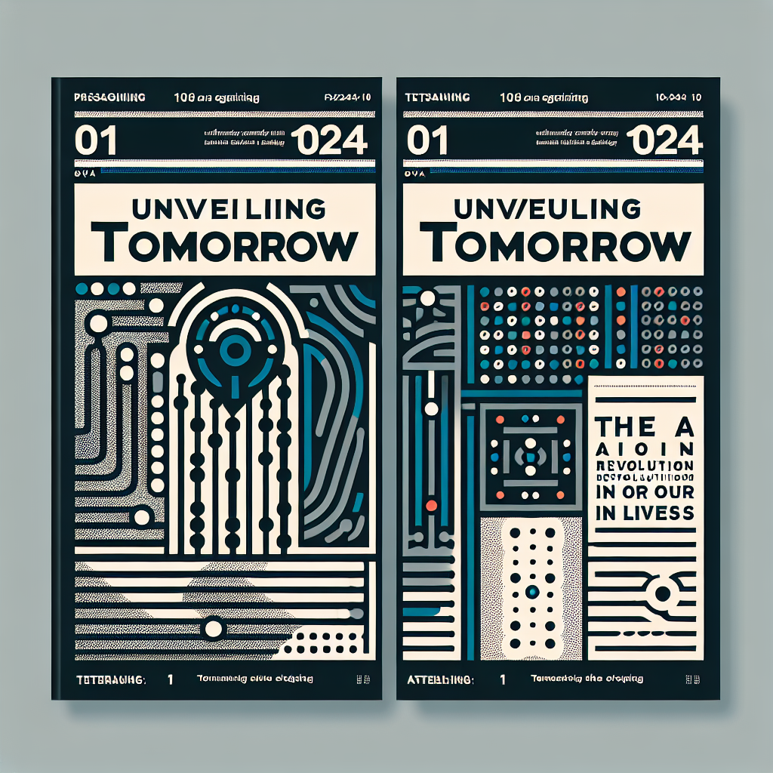

## Set 2: "Revolutionizing Reality: How AI is Transforming Our Lives" - This blog delves into the profound ways in which AI technology is reshaping our daily experiences and offers insightful perspectives on the transformative power of artificial intelligence in revolutionizing our reality.

Title: The Transformative Power of Artificial Intelligence in Our Daily Lives  
  
Introduction:  
Artificial Intelligence (AI) has swiftly become a pervasive force in our modern world, revolutionizing the way we live, work, and interact with technology. From virtual assistants like Siri and Alexa to personalized recommendations on streaming platforms, AI has embedded itself into our daily routines. In this blog post, we will explore the profound impact of AI on various aspects of our lives and delve into the opportunities and challenges it presents.  
  
Main Body:  
  
1. AI in Healthcare:  
One of the most significant areas where AI is making a substantial impact is healthcare. AI-powered technologies are being used for medical imaging analysis, disease diagnosis, personalized treatment plans, and drug discovery. These advancements have not only improved the efficiency and accuracy of healthcare services but also saved countless lives. For instance, AI algorithms can analyze medical images faster and with greater precision than human radiologists, leading to quicker diagnoses and treatment decisions.  
  
2. AI in Education:  
In the realm of education, AI is transforming the way students learn and teachers instruct. Adaptive learning platforms use AI algorithms to customize educational content based on individual student needs, enhancing engagement and improving learning outcomes. Furthermore, AI-powered chatbots are being employed to provide instant assistance to students, making education more accessible and interactive. While there are concerns about the potential replacement of human teachers, AI can be seen as a valuable tool to support educators in delivering personalized and effective instruction.  
  
3. AI in Transportation:  
The transportation industry is another sector experiencing a significant AI-driven transformation. Autonomous vehicles are a prime example of AI's impact on transportation, promising safer and more efficient means of travel. AI algorithms enable self-driving cars to navigate roads, interpret traffic signs, and respond to changing road conditions. While there are ongoing debates about the ethical and regulatory implications of autonomous vehicles, there is no denying the potential for AI to revolutionize the way we commute and transport goods.  
  
4. AI in Finance:  
AI technologies are also reshaping the financial sector, with applications ranging from fraud detection to algorithmic trading. Machine learning algorithms can analyze vast amounts of financial data in real-time to detect suspicious activities and prevent fraudulent transactions. Moreover, AI-powered robo-advisors provide personalized investment recommendations based on individual risk profiles and financial goals. While AI has undoubtedly enhanced the efficiency of financial services, there are concerns about data privacy and algorithmic bias that need to be addressed.  
  
Conclusion:  
In conclusion, the impact of AI in our lives is profound and multifaceted, touching upon various aspects of society. While AI presents incredible opportunities for innovation and advancement, it also raises ethical, social, and economic challenges that must be carefully navigated. As we continue to embrace AI technologies, it is essential to strike a balance between leveraging its benefits and mitigating its risks. By fostering a thoughtful and responsible approach to AI integration, we can harness its transformative power to create a more inclusive and sustainable future for all.

### Cover Image:

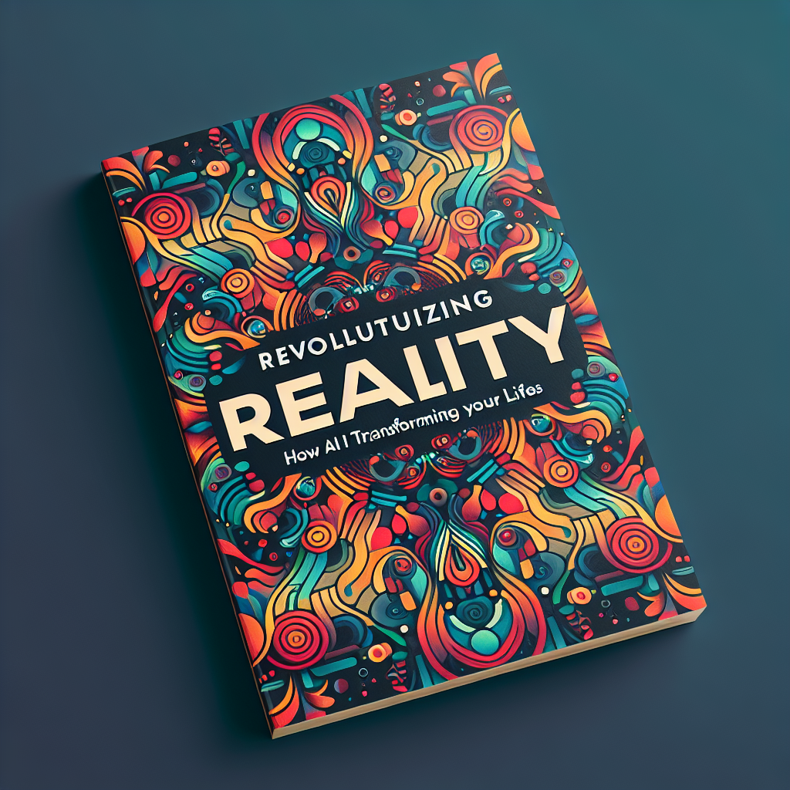

## Set 3: "AI Revolution: Transforming Lives with Intelligent Technology" - This blog creatively delves into how the AI revolution is significantly impacting and transforming various aspects of our daily lives through intelligent technology.

Title: Embracing the Evolution: The Impact of AI in Our Lives  
  
Introduction:  
Artificial Intelligence (AI) has become an integral part of our daily lives, revolutionizing the way we interact with technology and reshaping various industries. From virtual assistants like Siri and Alexa to self-driving cars and recommendation systems, AI has made remarkable strides in enhancing efficiency, convenience, and innovation. In this blog post, we will explore the profound impact of AI on our lives and how it is shaping our future.  
  
Main Body:  
1. Advancements in Healthcare:  
AI has revolutionized the healthcare industry by enabling early disease detection, personalized treatment plans, and predictive analytics. Machine learning algorithms can analyze vast amounts of medical data to diagnose diseases accurately and recommend optimal treatment options. This has the potential to save countless lives and improve patient outcomes. Moreover, AI-powered robots are assisting surgeons in complex procedures, leading to more precise and efficient surgeries.  
  
2. Enhanced Customer Experience:  
AI has transformed the way businesses interact with customers by providing personalized recommendations, predictive analytics, and efficient customer service. Chatbots powered by AI can handle customer queries around the clock, improving response times and enhancing customer satisfaction. E-commerce platforms use AI algorithms to suggest products based on customers' preferences and purchase history, leading to increased sales and customer loyalty.  
  
3. Automation and Efficiency:  
AI has automated routine tasks across various industries, leading to increased productivity and efficiency. In manufacturing, AI-powered robots can perform repetitive tasks with high precision and speed, reducing human error and production costs. In the financial sector, AI algorithms analyze market trends and make data-driven investment decisions, optimizing portfolio performance and risk management. AI-driven automation is reshaping the workforce and creating new opportunities for innovation and growth.  
  
4. Ethical Considerations:  
While the advancements in AI bring numerous benefits, they also raise ethical concerns regarding data privacy, algorithm bias, and job displacement. It is crucial to ensure transparency and accountability in AI systems to prevent misuse and discrimination. Additionally, efforts must be made to upskill the workforce and prepare for the changing job landscape driven by automation and AI technologies. Striking a balance between technological progress and ethical considerations is essential to harness the full potential of AI for societal good.  
  
Conclusion:  
In conclusion, the impact of AI in our lives is profound and far-reaching, transforming the way we live, work, and interact with the world around us. Embracing the evolution of AI presents exciting opportunities for innovation, efficiency, and progress. By leveraging AI responsibly and ethically, we can harness its transformative power to create a brighter future for humanity. As we navigate the complexities of the AI-driven world, it is essential to remain vigilant, adaptable, and collaborative in shaping a future where humans and machines coexist harmoniously. Let us embrace the promise of AI and steer its course towards a more inclusive and sustainable future.

### Cover Image:

